DIGITAL ELECTRONICS AND LOGIC DESIGN [EC - 207]

**SARDAR VALLABHBHAI NATIONAL INSTITUTE OF TECHNOLOGY, SURAT ELECTRONICS ENGINEERING DEPARTMENT**

Name: Krishna Pandey

Adm. No: U20CS110

COMMON EMITTER AMPLIFIER

**AIM: -** To design common emitter or single stage RC Coupled Amplifier using BJT.

# SOFTWARE TOOLS/OTHER REQUIREMENTS: -

1.Multisim Simulator/Circuit Simulator.

# THEORY:

All types of transistor amplifiers operate using AC signal inputs which alternate between a positive value and a negative value so some way of “presetting” the amplifier circuit to operate between these two maximum or peak values is required. This is achieved using a process known as Biasing. Biasing is very important in amplifier design as it establishes the correct operating point of the transistor amplifier ready to receive signals, thereby reducing any distortion to the output signal.

The aim of any small signal amplifier is to amplify all of the input signal with the minimum amount of distortion possible to the output signal, in other words, the output signal must be an exact reproduction of the input signal but only bigger (amplified).

To obtain low distortion when used as an amplifier the operating quiescent point needs to be correctly selected. This is in fact the DC operating point of the amplifier and its position may be established at any point along the load line by a suitable biasing arrangement. The best possible position for this Q-point is as close to the center position of the load line.

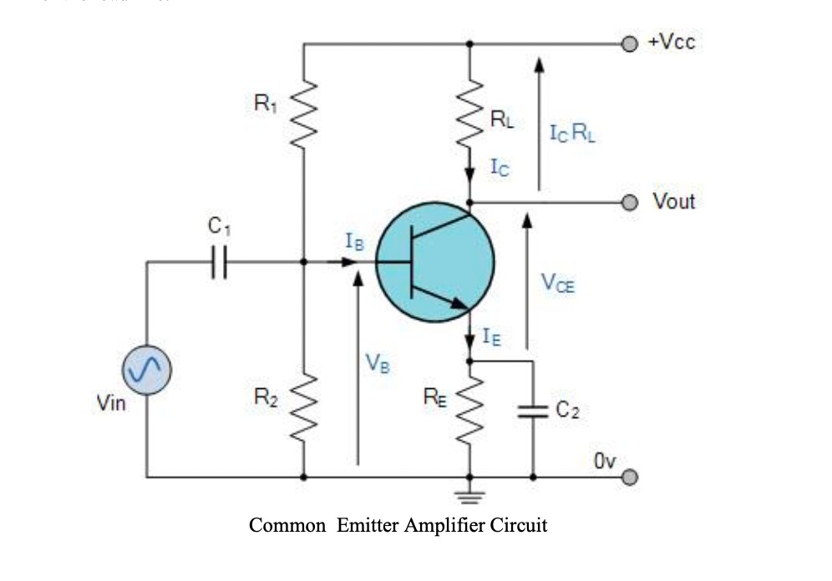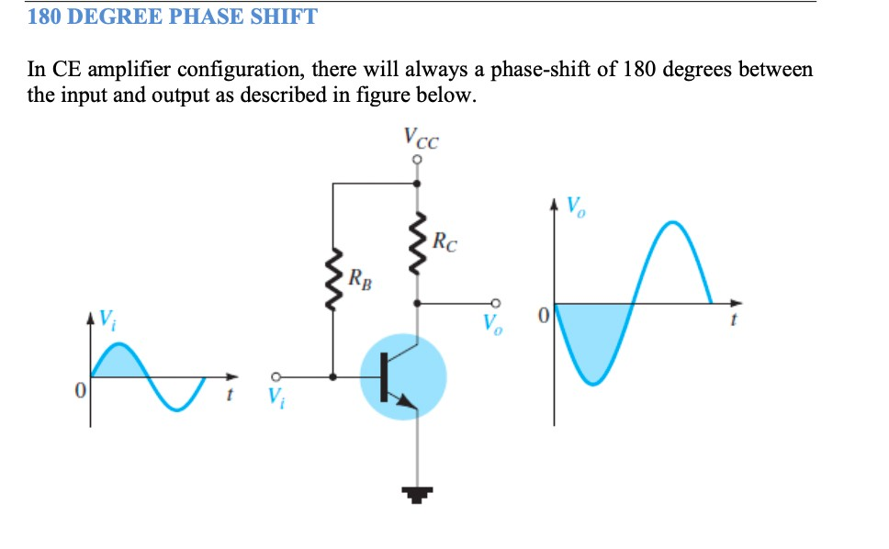

# CIRCUIT DIAGRAM FROM MULTISIM



**INPUT – OUTPUT WAVEFORMS**

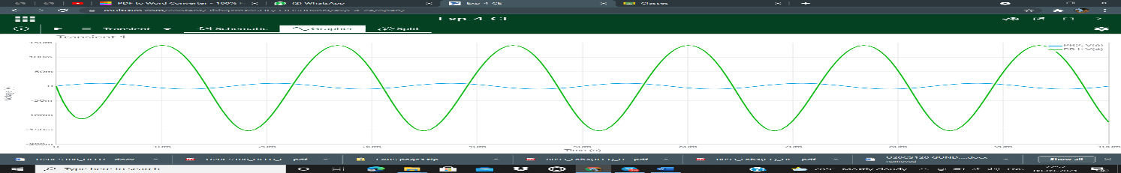

**CONCLUSIONS**

Common emitter amplifier develops voltage output due to the current through the load resistor. With the solar cell darkened (no current), the transistor will be in cutoff mode and behave as an open switch between collector and emitter. FROM THE OUTPUT OF CE AMPLIFIER GRAPH IT CAN OBSERVED THAT THE OUTPUT IS THE INVERTED AND AMPLIFIED FORM OF INPUT.